**M3 Practical Challenge:**

**Cleansing Your Data with Alteryx**

The objective is to get a database of the market capitalization of the S&P 500 companies and an evolution of the prices of the stocks of that companies during a period of time.

Once that’s done, I’m going to calculate the [Stochastic Relative Strength Index](https://www.investopedia.com/terms/s/stochrsi.asp) or StocRSI for a couple of companies, in this case Apple and Facebook. After that plot the results on a graph.

Another process I will be doing is creating two tops_10 of the Cities and States which have the most amount of S&P 500 Companies and show the sum Net income and sum Long-Term Debt of all the companies in that City or State.

Table of Contents

1. Importing the data 2

2. Create the WorkFlow 4

2.1. Organizing the imports 4

2.1.1. Prices 4

2.1.2. Securities 6

2.1.3. Fundamentals 8

2.2. Information by City and State 9

2.2.1. City 11

2.2.2. State 15

2.3. Stochastic Relative Strength index 17

2.3.1. Apple Inc 22

2.3.2. Facebook 28

2.4. Represent the data 29

3. Review 35

# Importing the data

First, we need to get the data. For that I’m going to make use of Kaggle to obtain 3 .csv files related with Stocks.

<https://www.kaggle.com/dgawlik/nyse/version/3?select=fundamentals.csv>

<https://www.kaggle.com/dgawlik/nyse/version/3?select=prices.csv>

<https://www.kaggle.com/dgawlik/nyse/version/3?select=securities.csv>

The First, fundamentals.csv file include 1,781 rows of data of 448 different companies from 2012 to 2017. Including information about different indicators, such as Net Income, Total Assets, Long-Term Debt…

The second, prices.csv file include 851,264 market prices of 501 companies from 2010 to 2017, day by day including the open, close, low, high and volume data.

The third, securities.csv file includes information about 505 companies such as its Ticker symbol, name, sector, industry, address, CIK identifier.

The input from fundamentals.csv is:

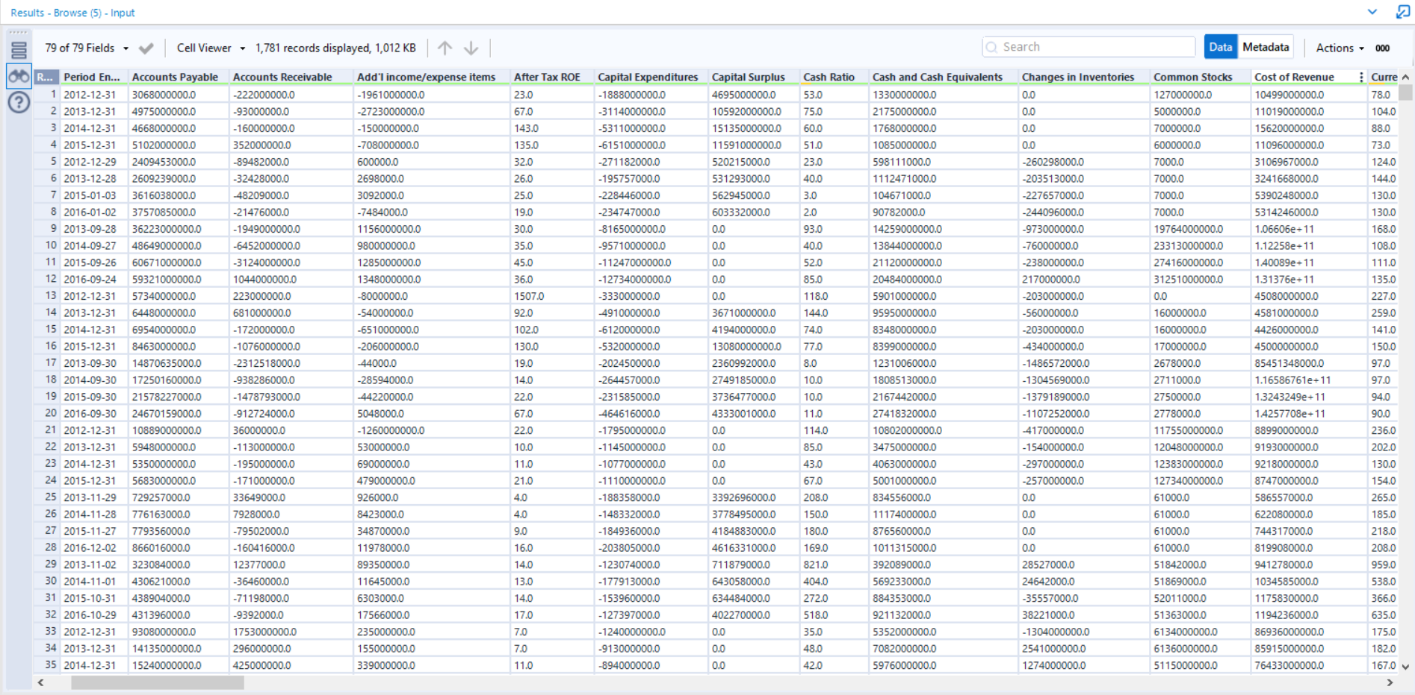

The input from prices.csv is:

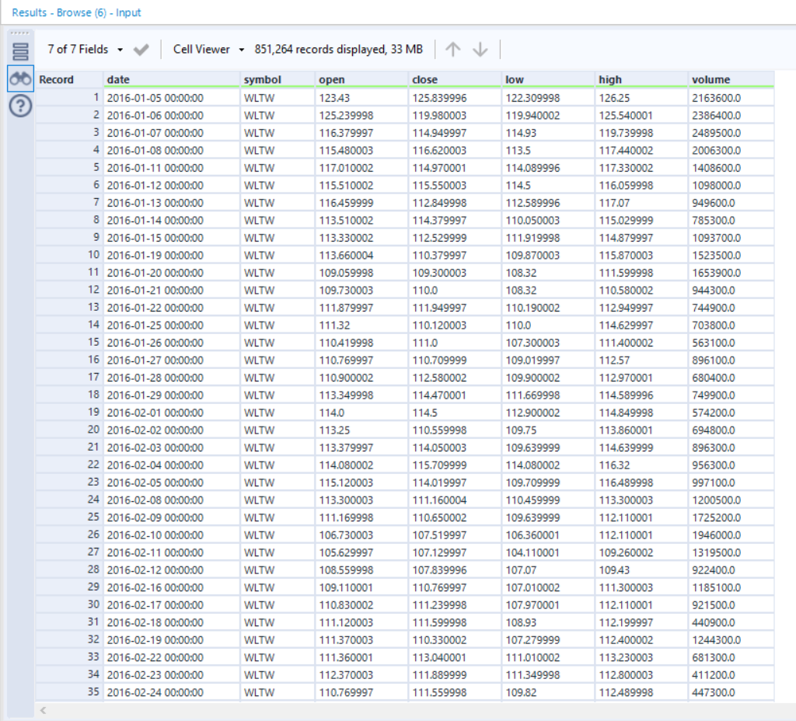

The input from securities.csv is:

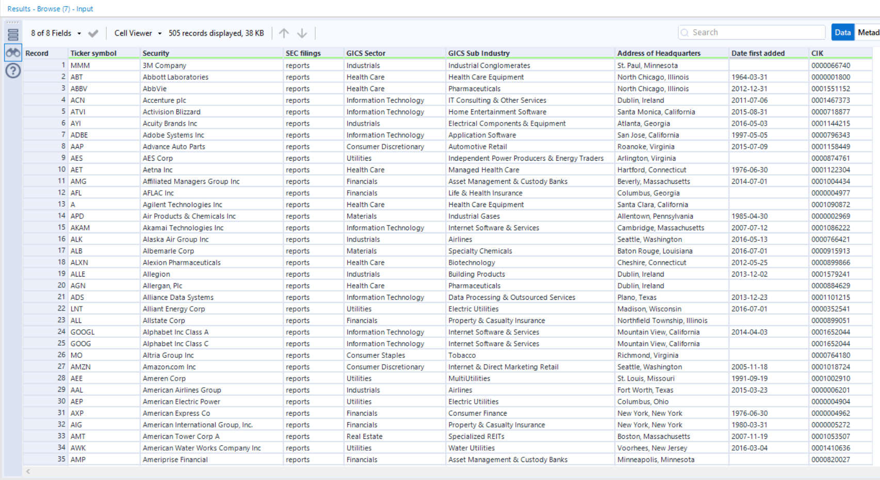

# Create the WorkFlow

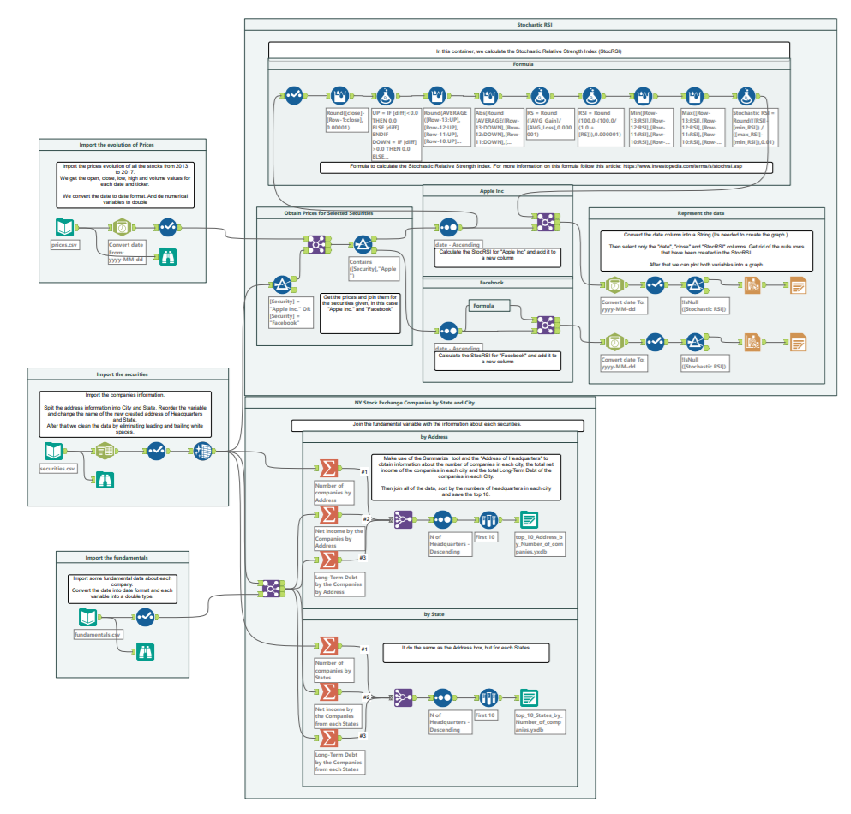

## Organizing the imports

The first thing that the workflow does is make the imports and treat the data to prepare it.

### Prices

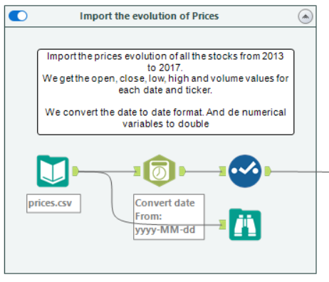

Import the prices.csv file, the first thing we need to do with this data is to change the date format, that’s because some of the fields have the format yyyy-MM-dd hh:mm:ss and others have the format yyyy-MM-dd, so we need to unify this field and change its type to date format.

For thar I used the DateTime tool to change the string into a Date format. Once that’s done, the select tool change the new date field into “date” and delete the original, as well as change the types of the numeric fields into double:

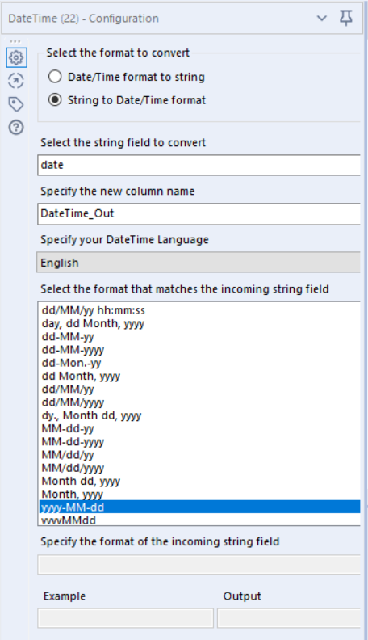 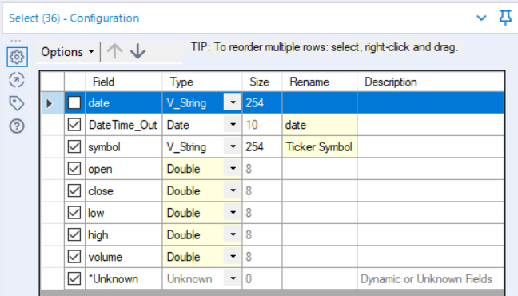

By doing the previous step we now have this information:

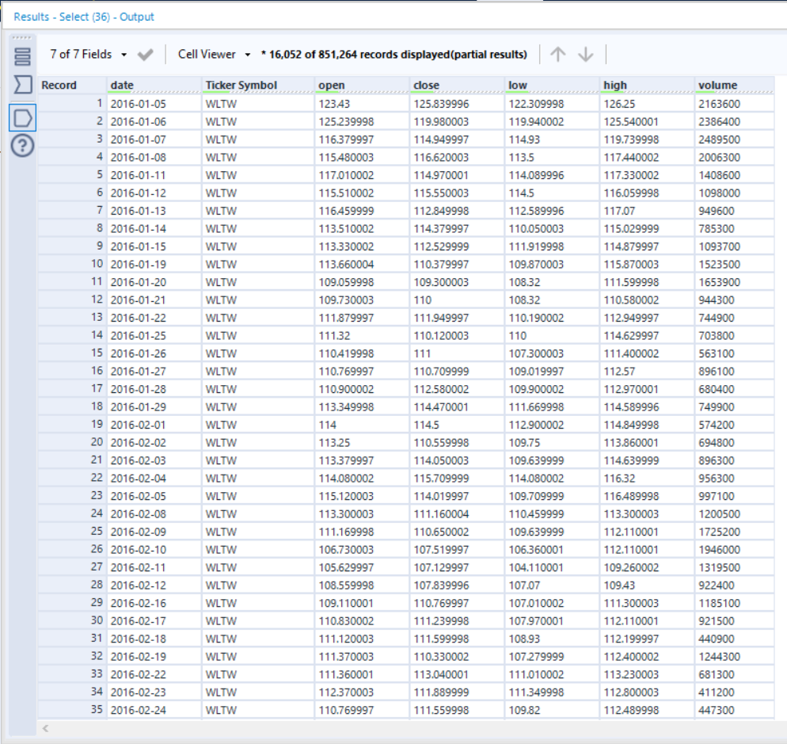

### Securities

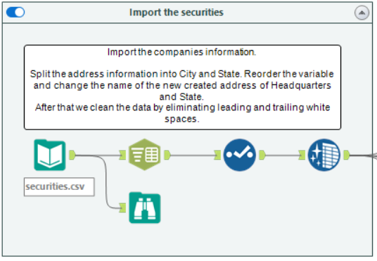

Import the Securities.csv file, the first thing that is done is using the Text To Columns tool to split the “Address of Headquarters” into the city and state (Some fields ends with ‘[number]’ so we need to get rid of that in order to unify the states). After that’s done, the Select tool is used to change the name of some of the newly created columns.

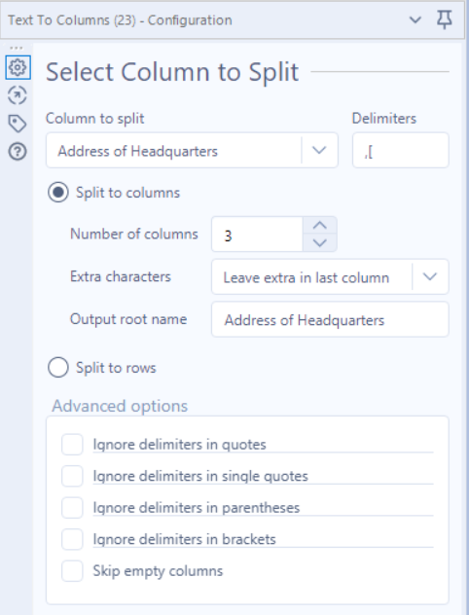 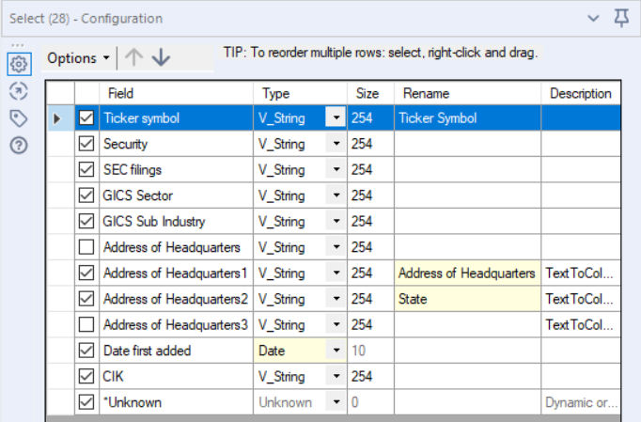

Lastly we clean the data using the Data Cleansing tool for the newly created variables, in order to ger rid of the leadinf and trailing whitspaces:

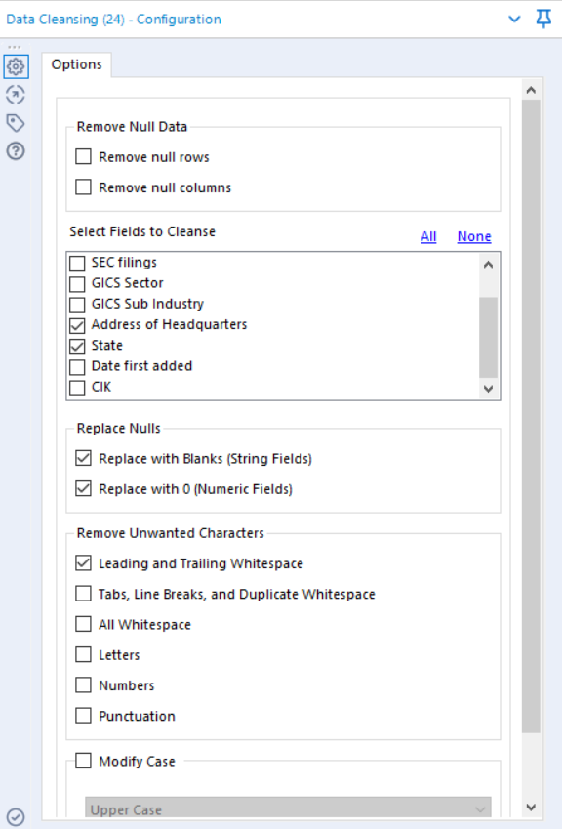

By doing the previous step we now have this information:

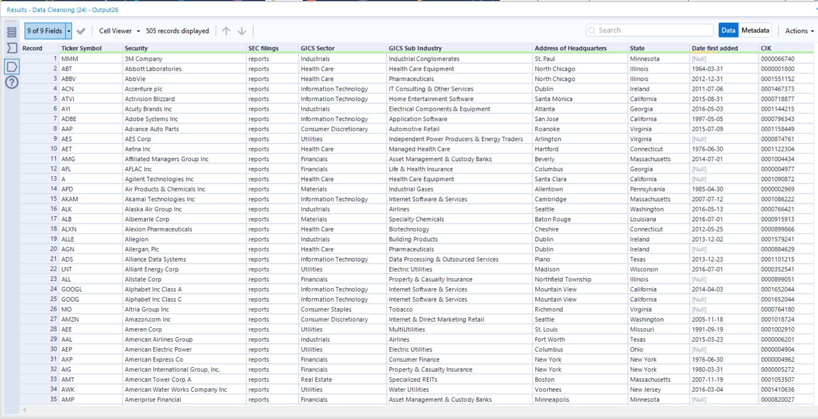

### Fundamentals

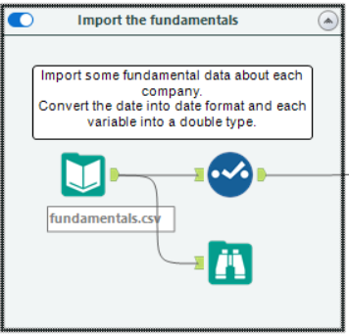

The only thing we need to do to this database is drop the column “Field_1” since it does not have any useful information, and change the type of all the numerical variables into double

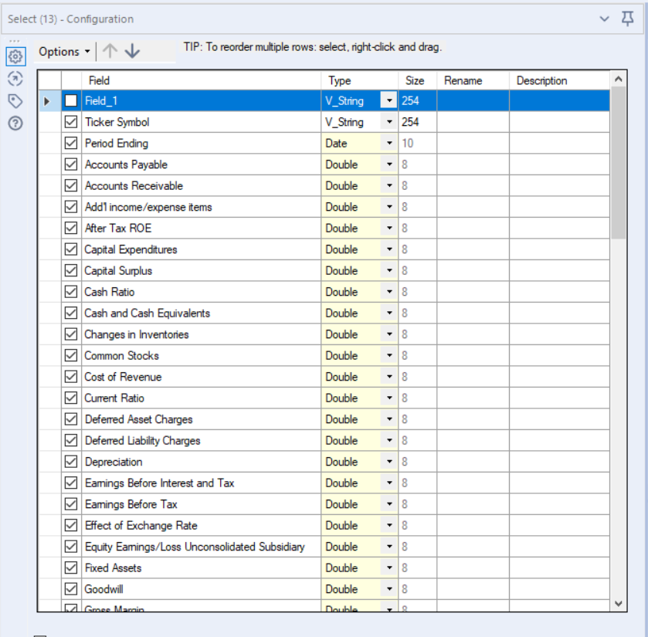

By doing the previous step we now have this information:

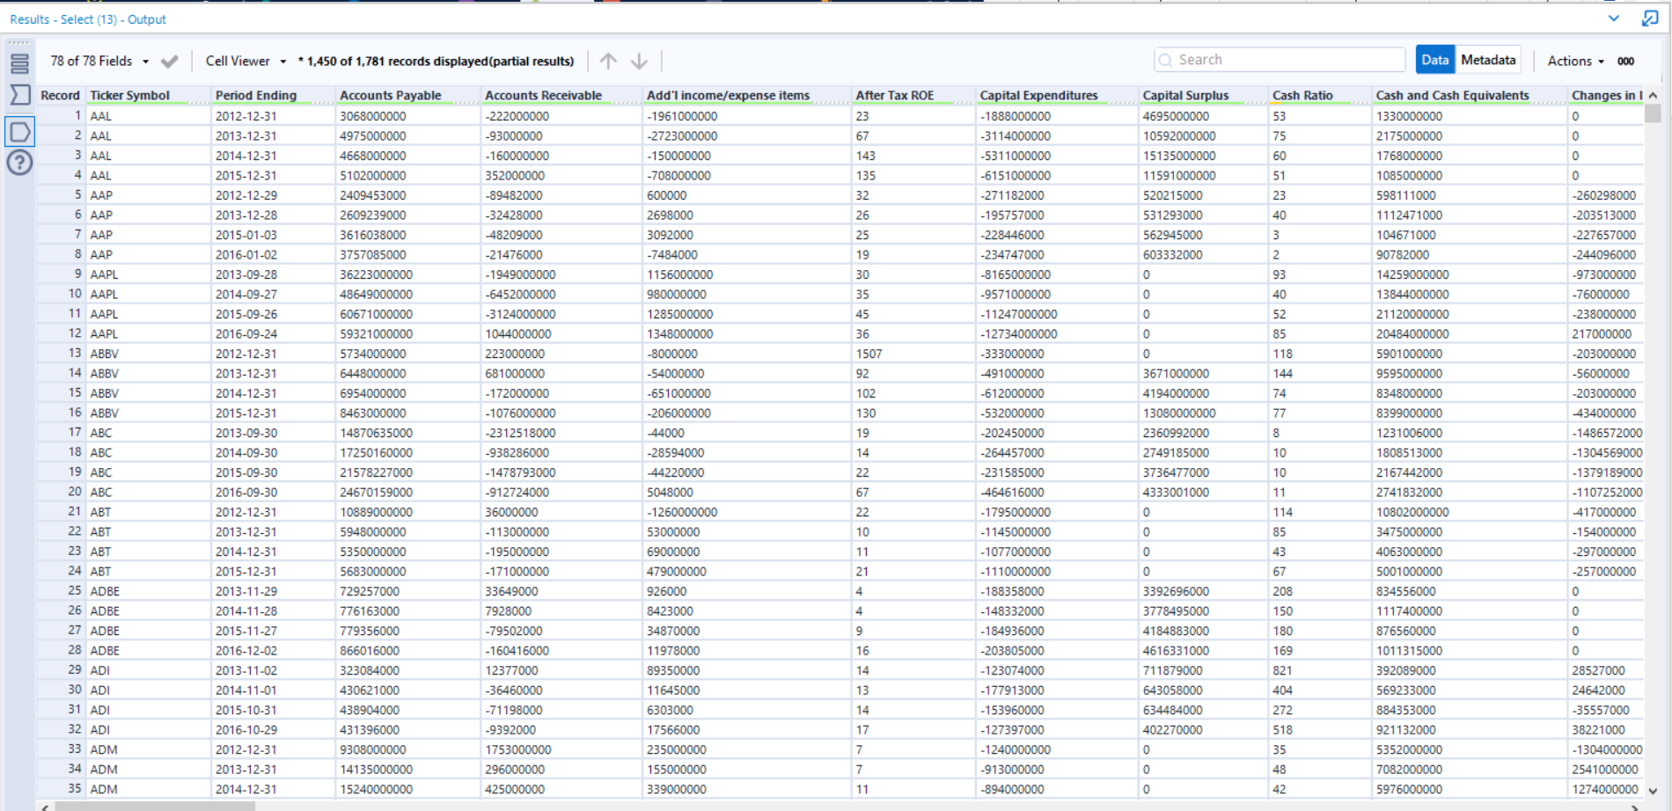

## Information by City and State

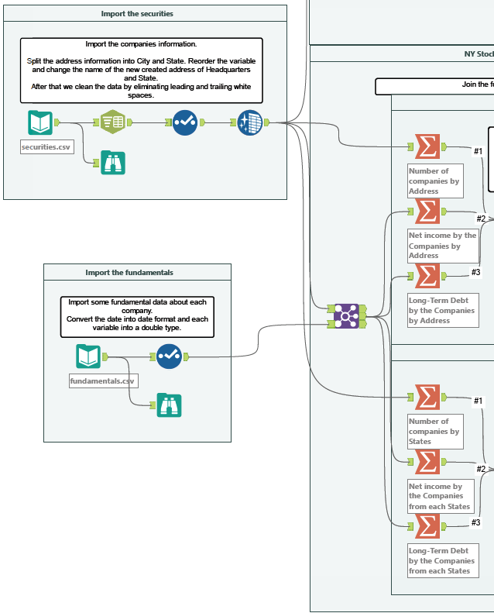

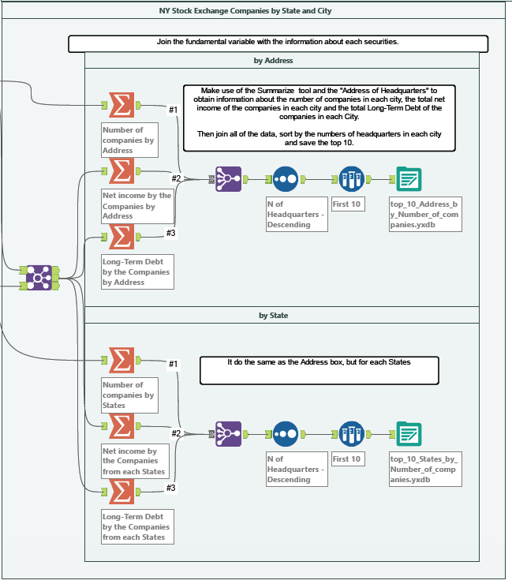

We now join the securities and fundamentals databases using the Ticker Symbol as the key, as it’s shown in the next photo.

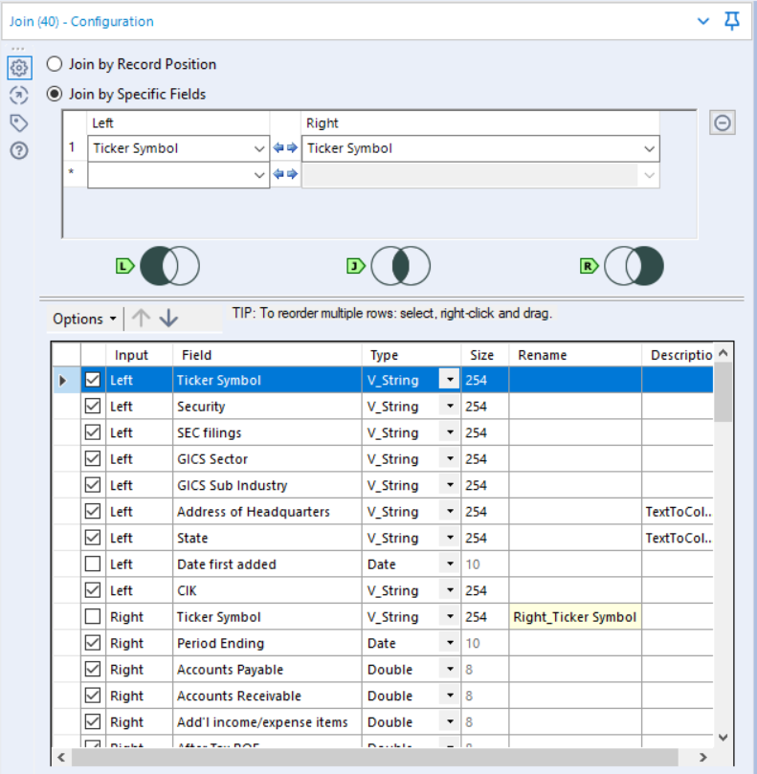

### City

Now we can get information at a city level, for that we follow the next workflow:

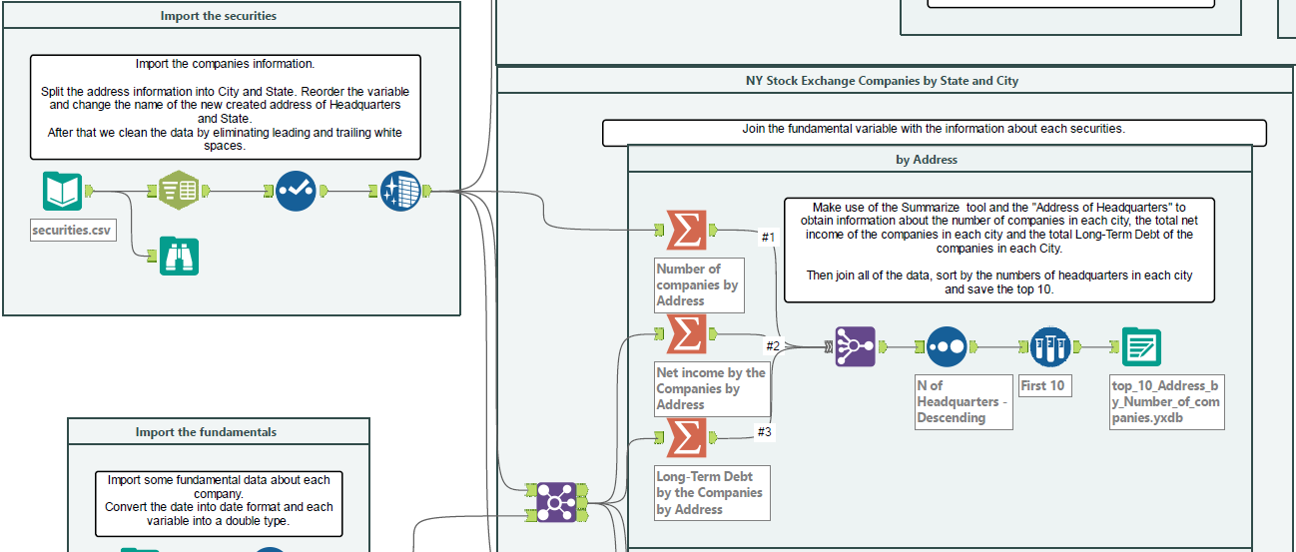

We connect the output from the securities into a Summarize tool, where we group all the rows by the Address of Headquarters and count them. That way we can know the number of companies that have the HQ in each city.

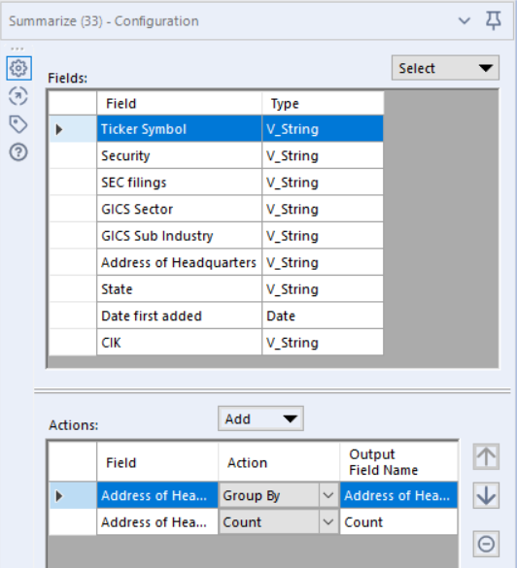

After thar the pass the output of the previous join into two others Summarize tool, where be Sum the fields Net Income and Long-Term Debt respectively.

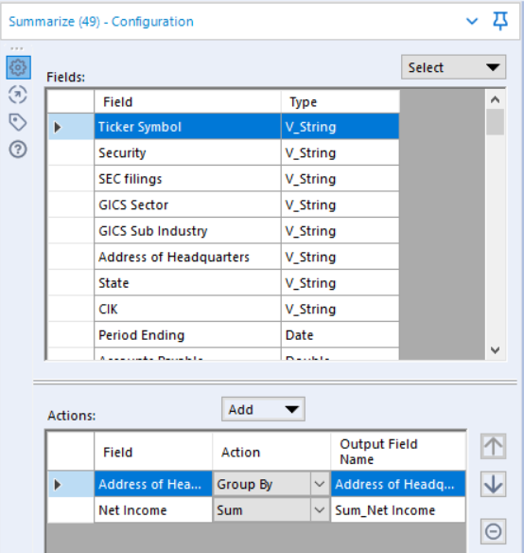 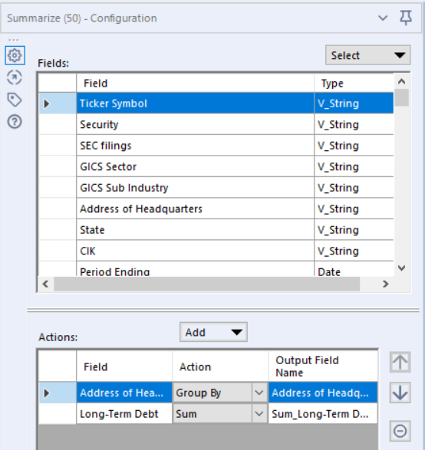

We now make use of the Join Multiple tool to combine the three previous outputs, using the address as key.

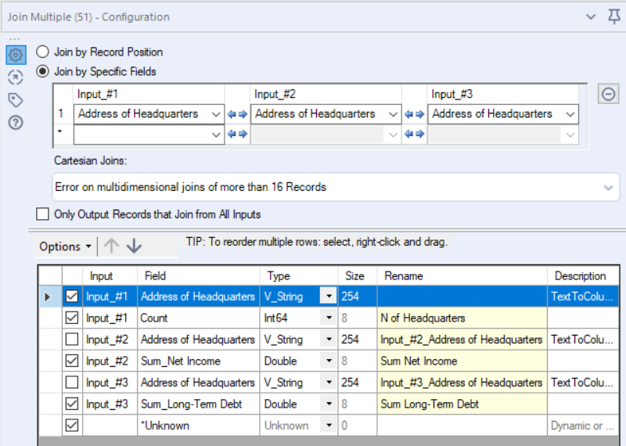

By doing this we get the following output:

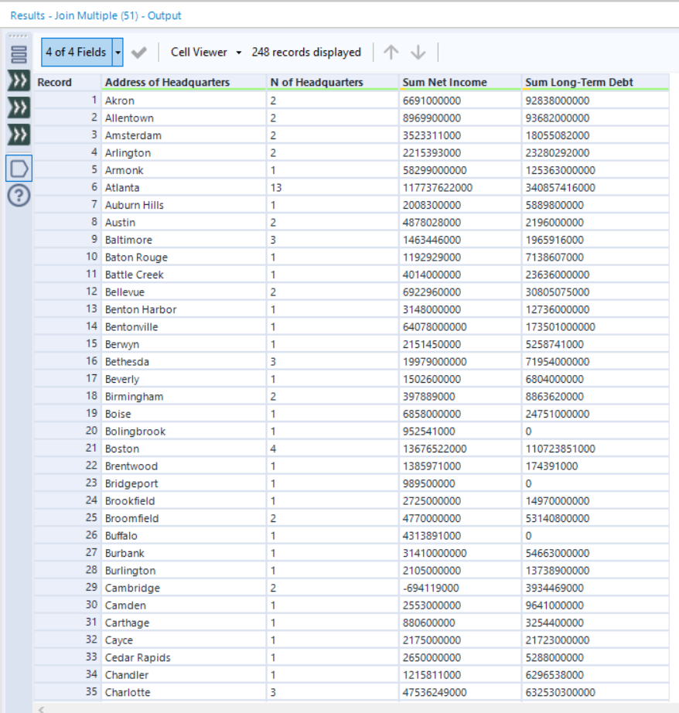

Since we only want the top 10 cities by number of companies, we now order them using the Sort tool and sample the 10 first using the Sample tool.

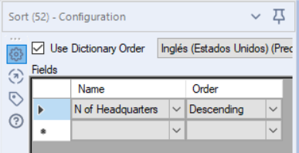 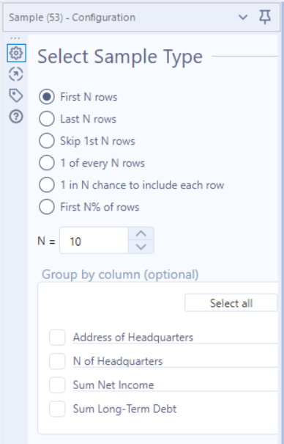

After all, we now can output and save the result using the Output Data tool.

The result is:

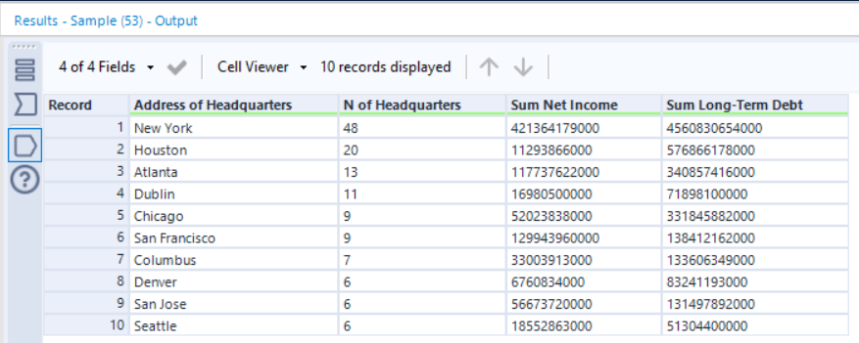

### State

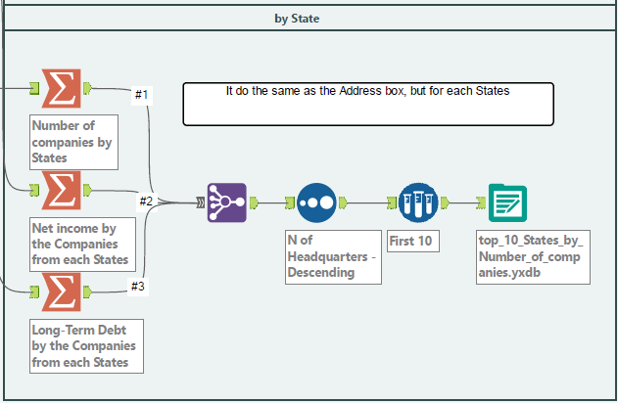

This is the same schema for city, the only difference is in the Summarize tool use the State variable instead of the Address of Headquarters.

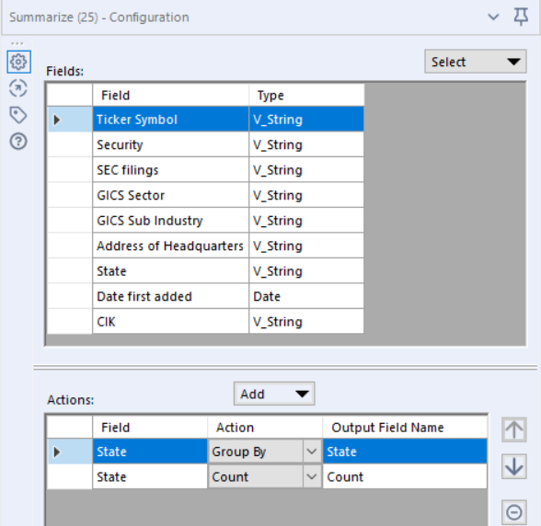 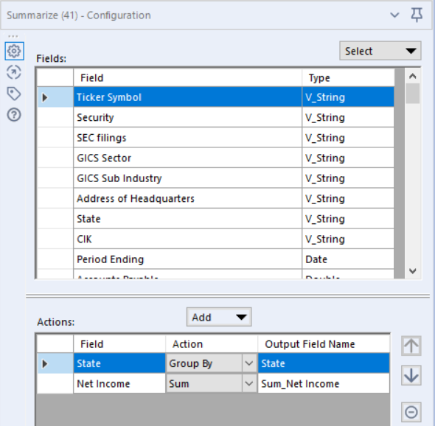 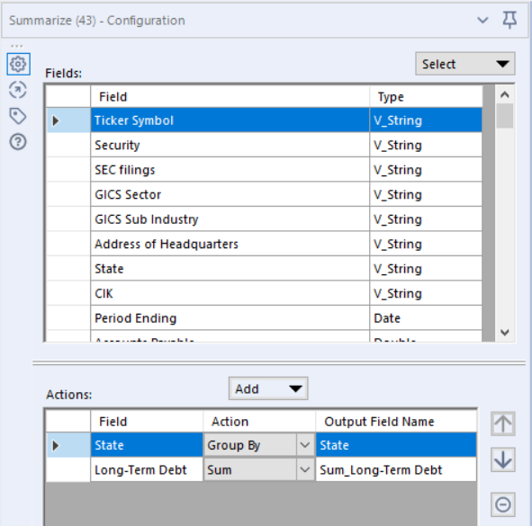

The final result is:

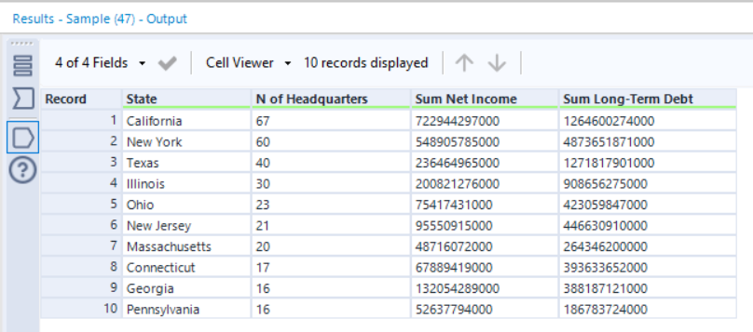

## Stochastic Relative Strength index

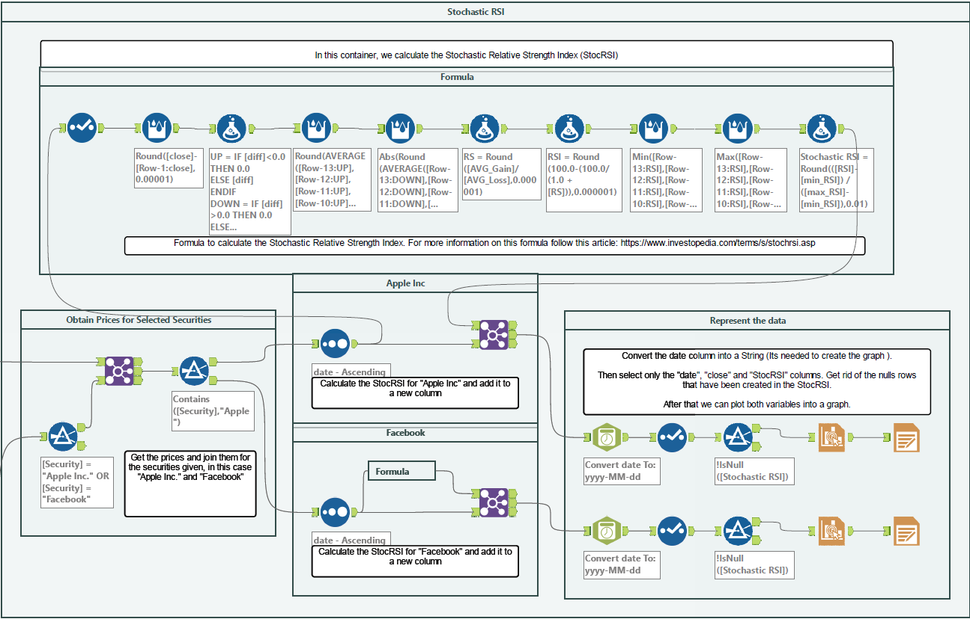

First, we need to get the data with which we are going to work. In order to calculate the StocRSI we need the prices evolution of a stock, we can get all the prices from the prices.csv import, and we need to know for which company we are going to calculate the StocRSI. We can get that from the securities.csv import.

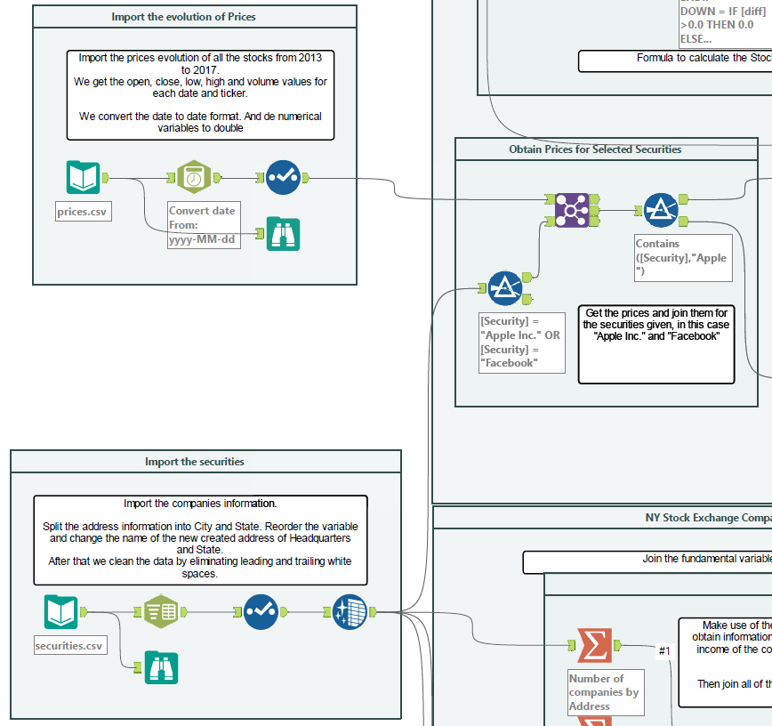

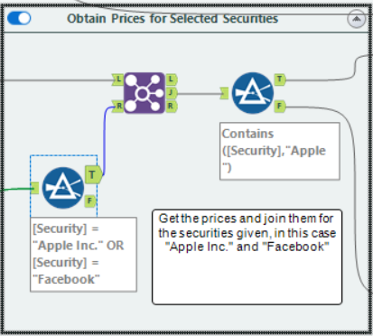

From the secutities.csv import, we apply a Filter tool, in order to get only the securities “Apple Inc” and “Facebook”.

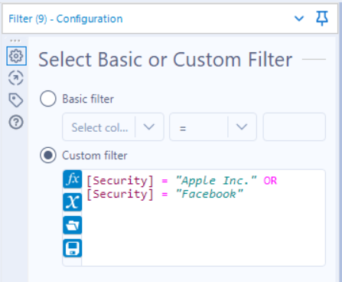

We now make use of the Join tool to get from the prices, only the ones that have the “Ticker Symbol” corresponding to “Apple” or “Facebook”.

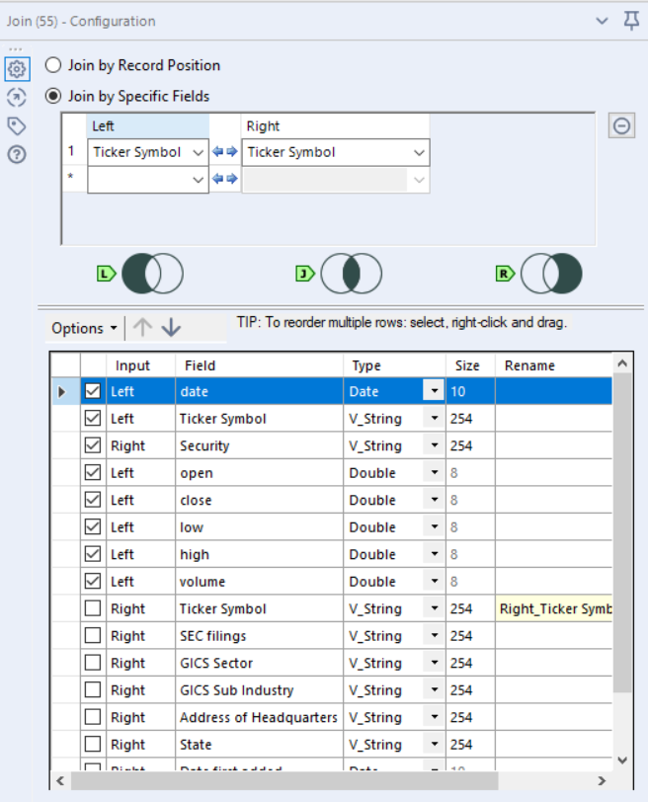

Lastly, we split both companies using the Filter tool so that we can apply the formula to each stock independently.

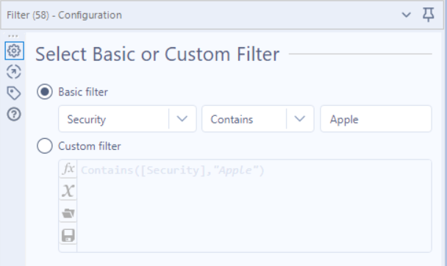

That way we get the following two outputs:

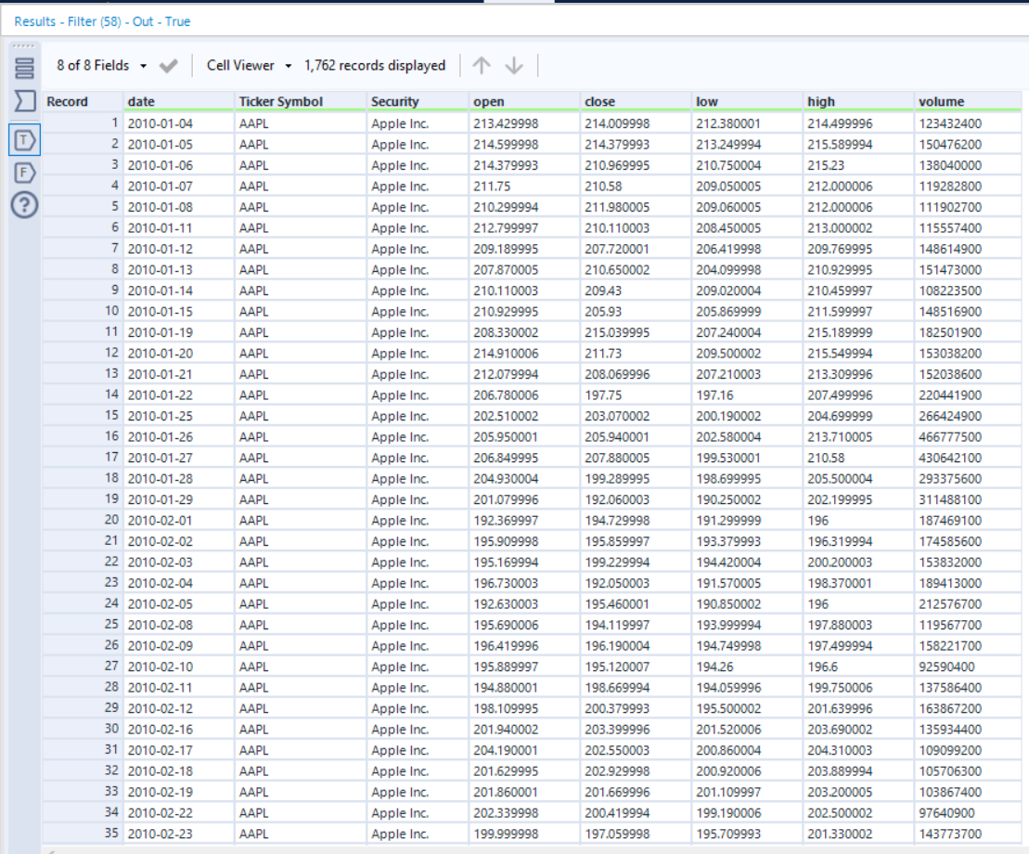

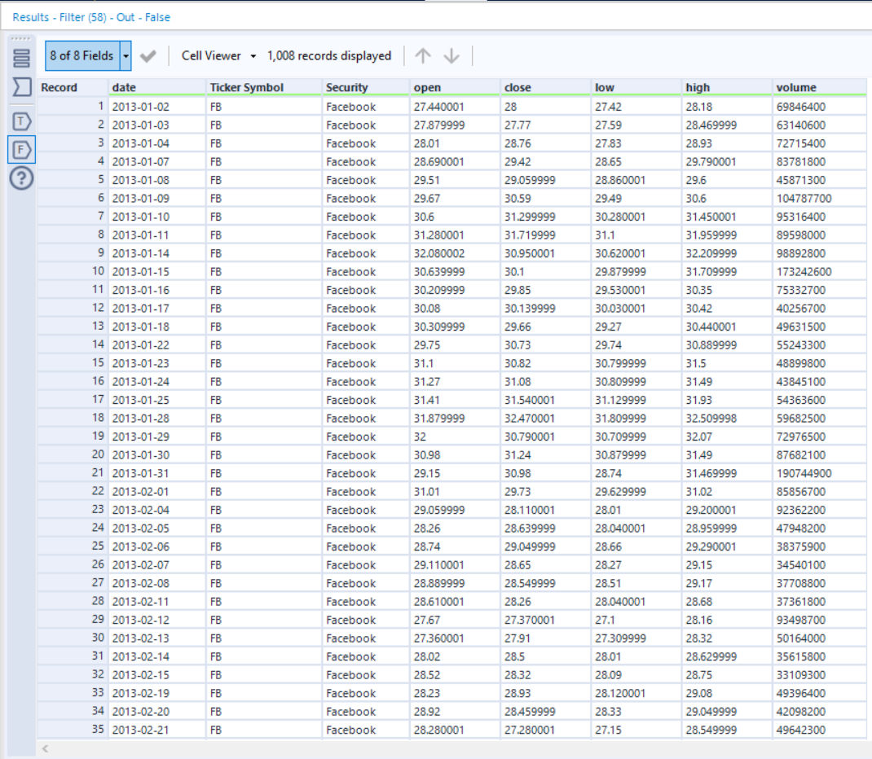

Now we can operate each company independently:

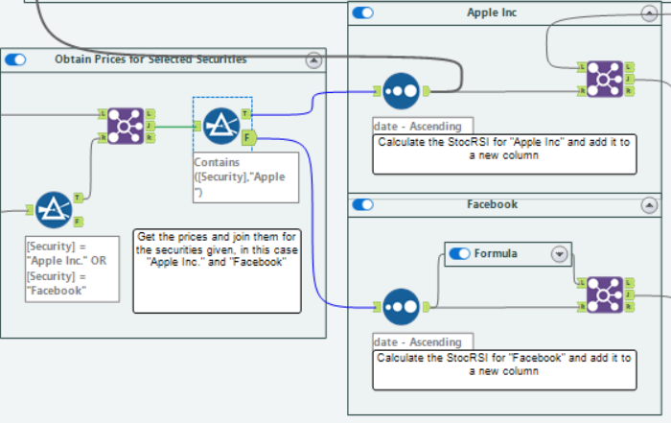

### Apple Inc

The first thing that is need is to order the prices by date, to maintain a chronological order.

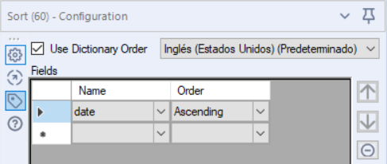

We now apply the formula:

#### Formula

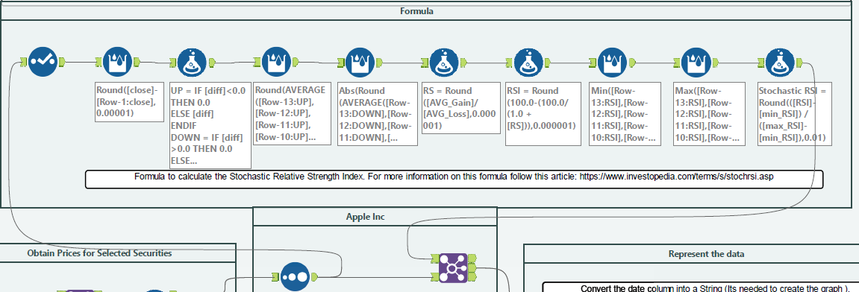

1. Select tool: Is used to get the date and Close variables, since it’s the one we are going to use:

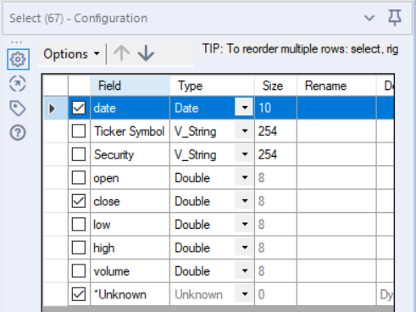

1. Multi-Row Formula tool: It’s used to get the difference between the close price and the close price of the previous date:

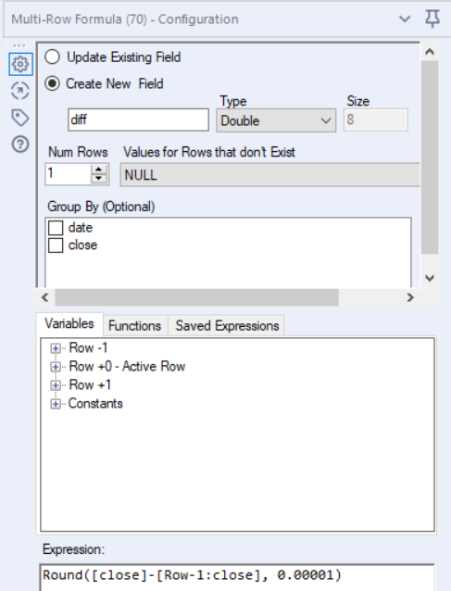

1. Formula tool: It’s used to create 2 new Columns, “UP” and “DOWN”, in the up column the difference which are negative get change to 0, and in the down column the positive values are change to 0. Here I make use of a conditional IF statement.

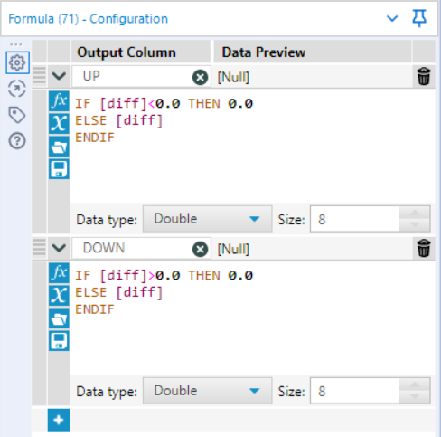

1. Multi-Row Formula tool: This tool is used to create a moving average for the UP column of 14 periods.

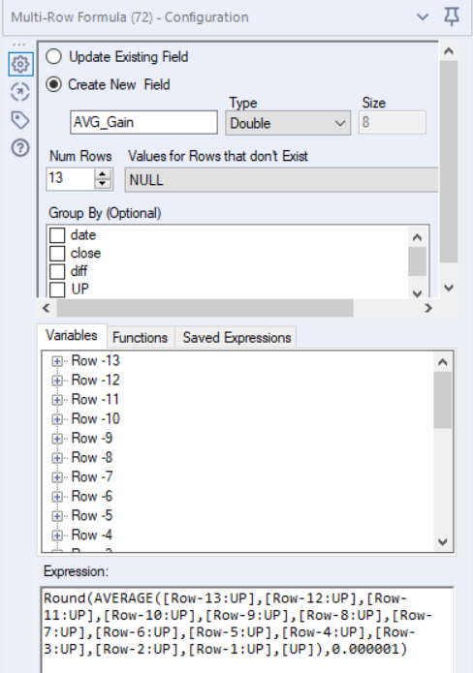

1. Multi-Row Formula tool: This tool is used to create a moving average for the DOWN column of 14 periods. (In this case be need the absolute value)

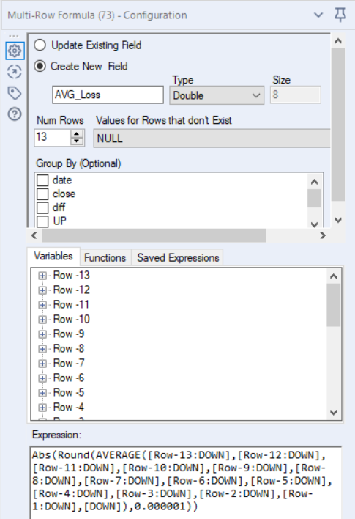

1. Formula tool: We make use of the Average gains and Average loss to calculate the RS

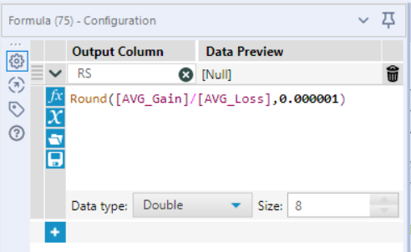

1. Formula tool: We make use of the RS to calculate the index: RSI

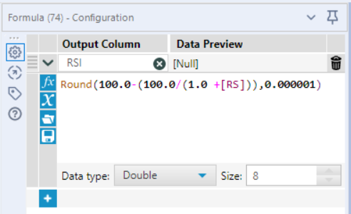

1. Multi-Row Formula tool: We get the min value of the RSI in a period of 14.

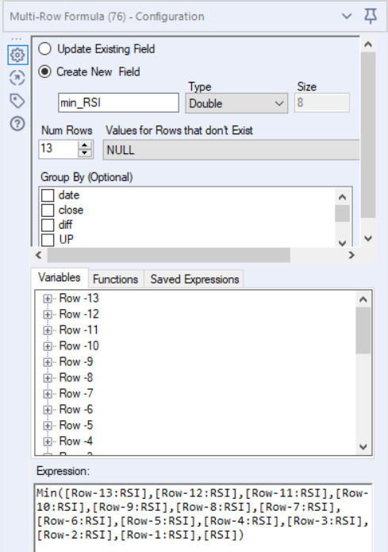

1. Multi-Row Formula tool: We get the max value of the RSI in a period of 14.

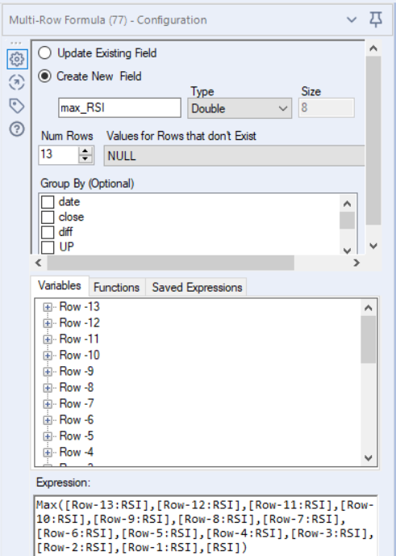

1. Formula tool: We need a last formula to calculate the StocRSI, using the RSI, min_RSI and max_RSI

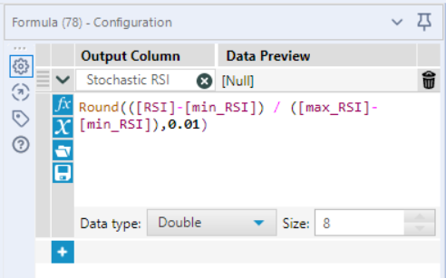

After the formula is done we get the following result:

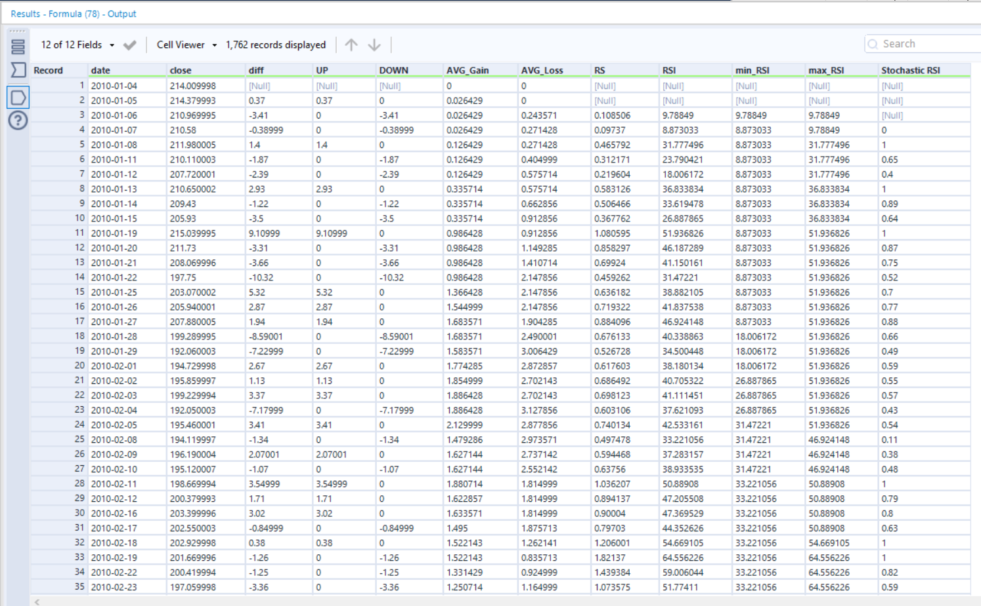

Once we are done with the formula, we add the StocRSI into the stock price data base we start with using a Join tool and using the date a s the key.

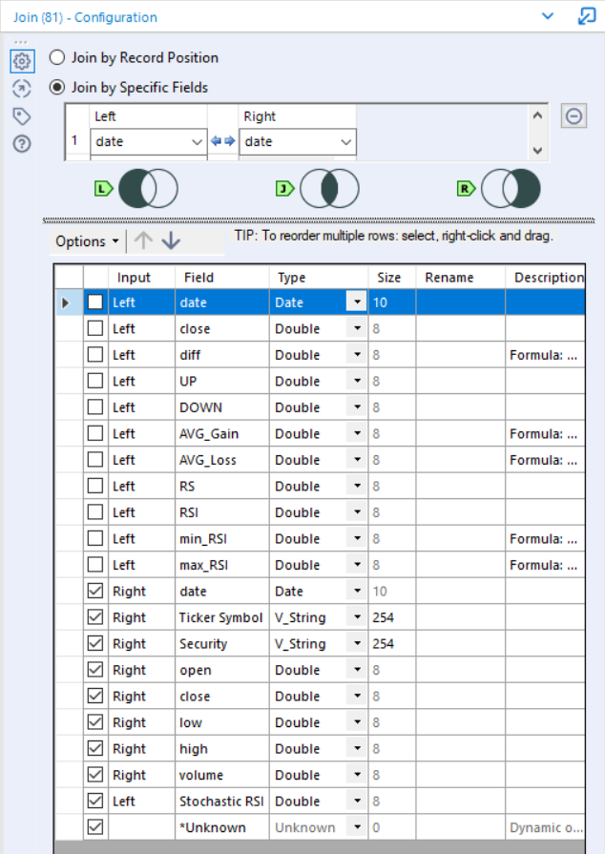

After doing this we get the following result:

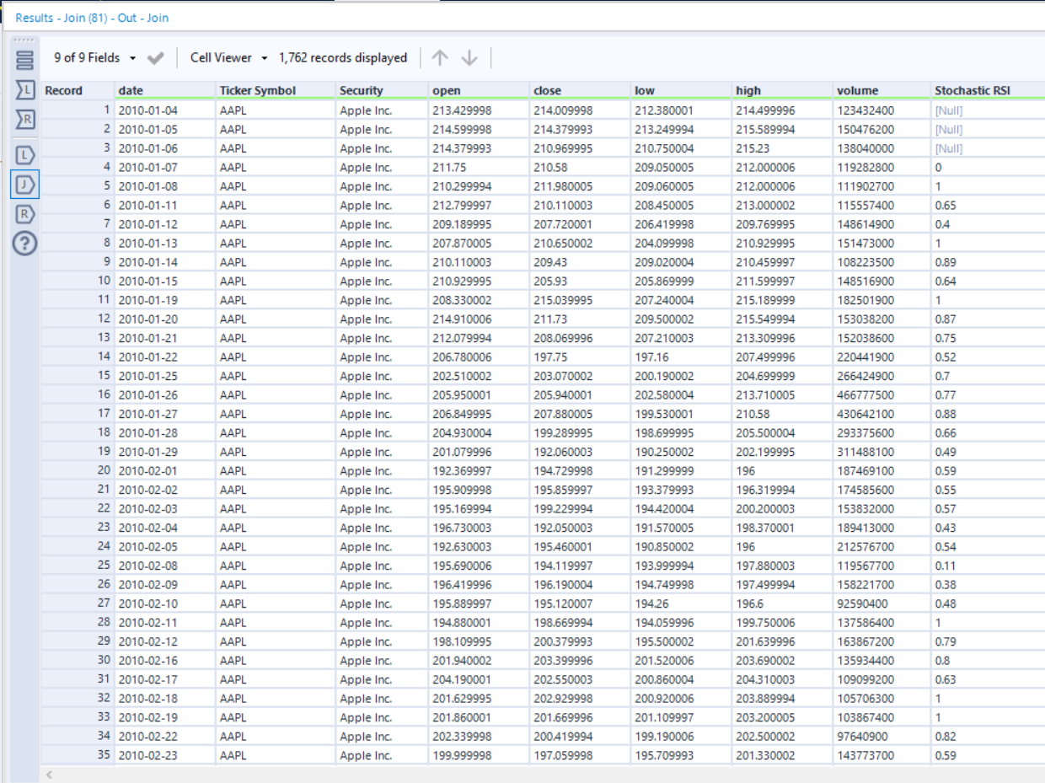

### Facebook

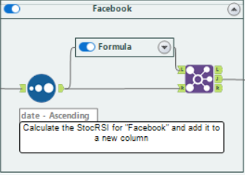

We follow the exact same process for “Facebook”, and get the following result:

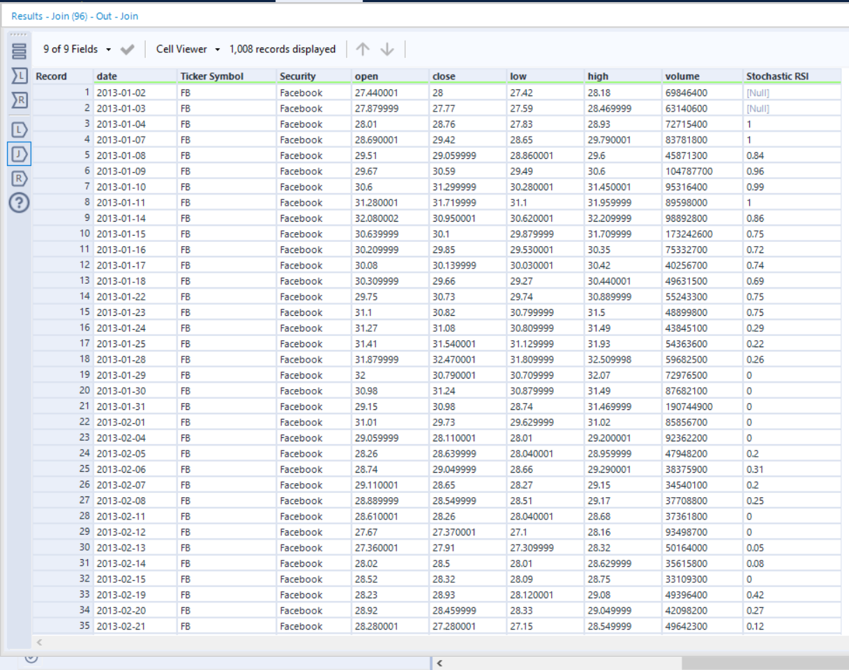

## Represent the data

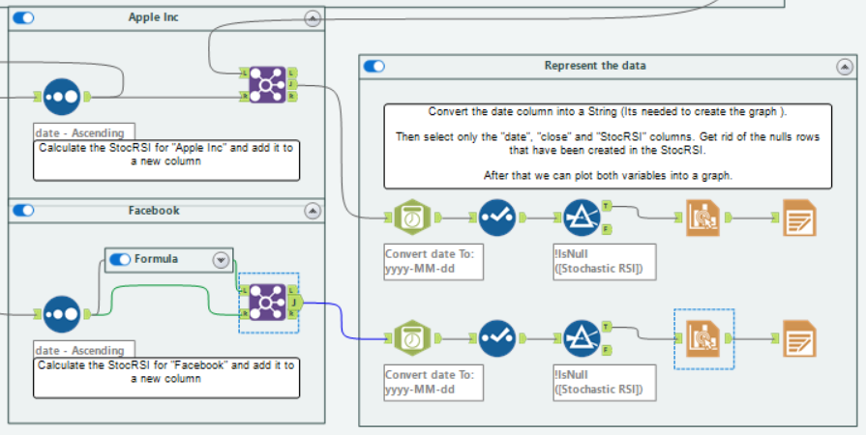

In order to create an Interactive graph, the date need to be converted into a String,

For that I make use of the DateTime tool, once I’m done with the date, I make use of the select tool to get only the variables that we need to plot: “date”, “close” and “Stochastic RSI”.

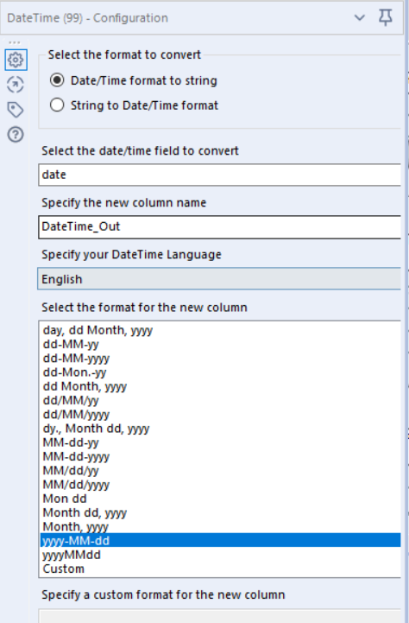 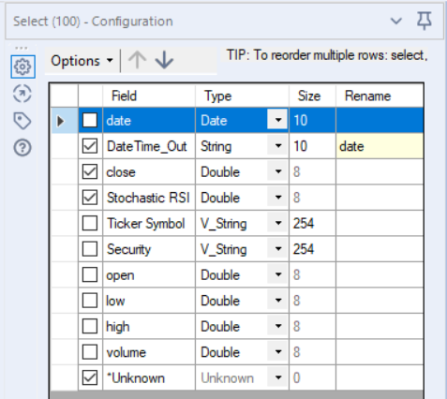

Since the Stochastis RSI formula created some nulls values at the bigining of the time series, we need to get rid of them using the filter:

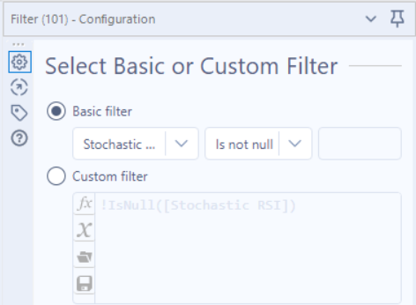

Now we can plot the graphs using the Interactive Chart tool:

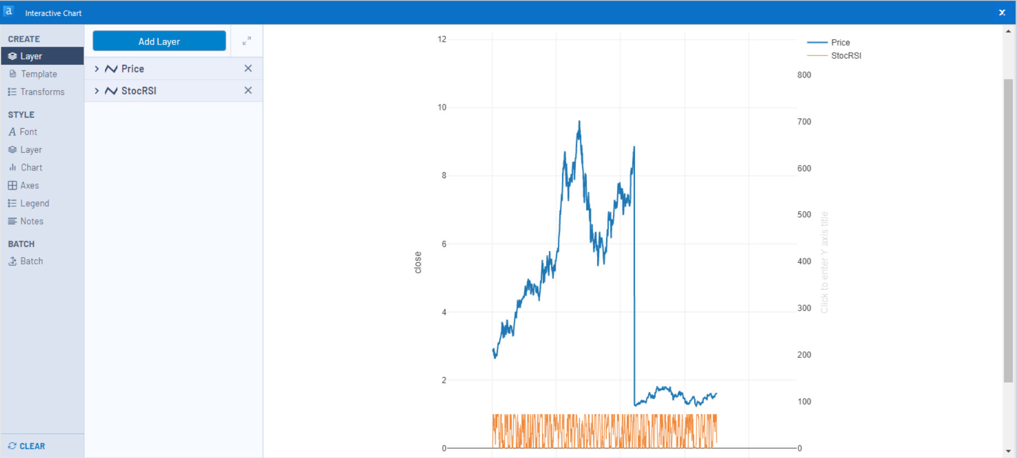

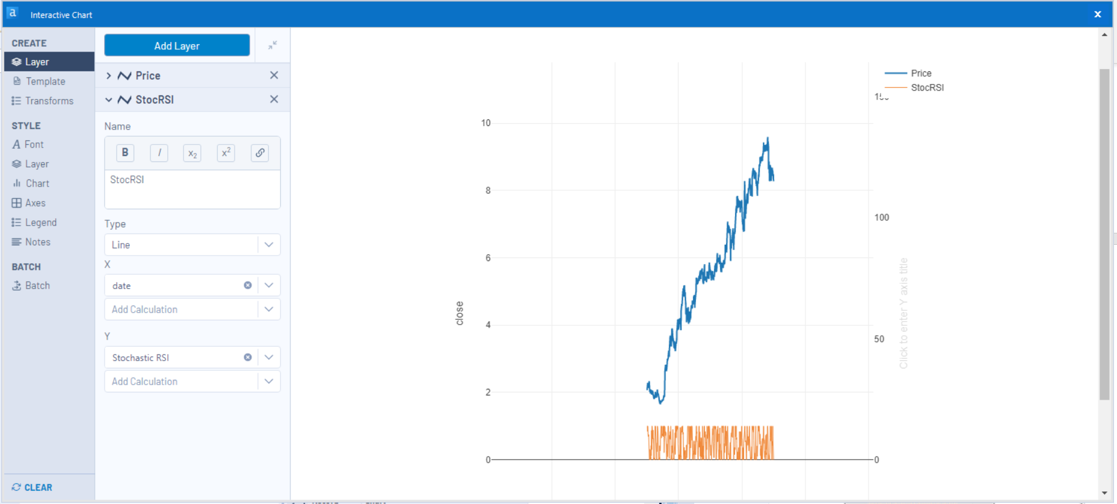

Lastly we use the Render tool to output the files:

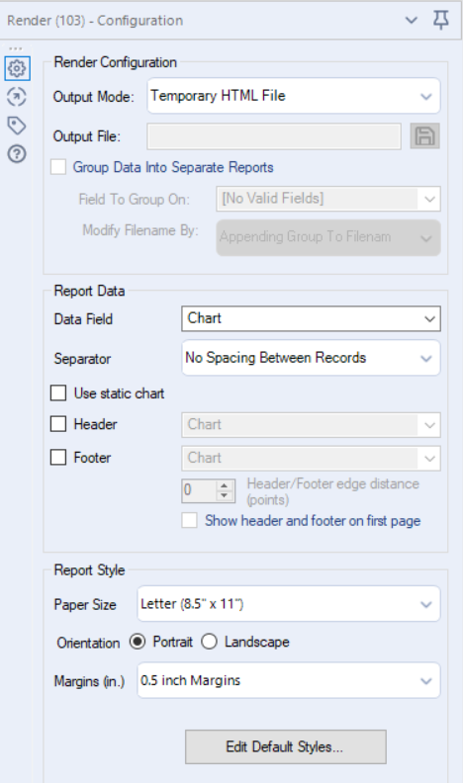

Getting the following files:

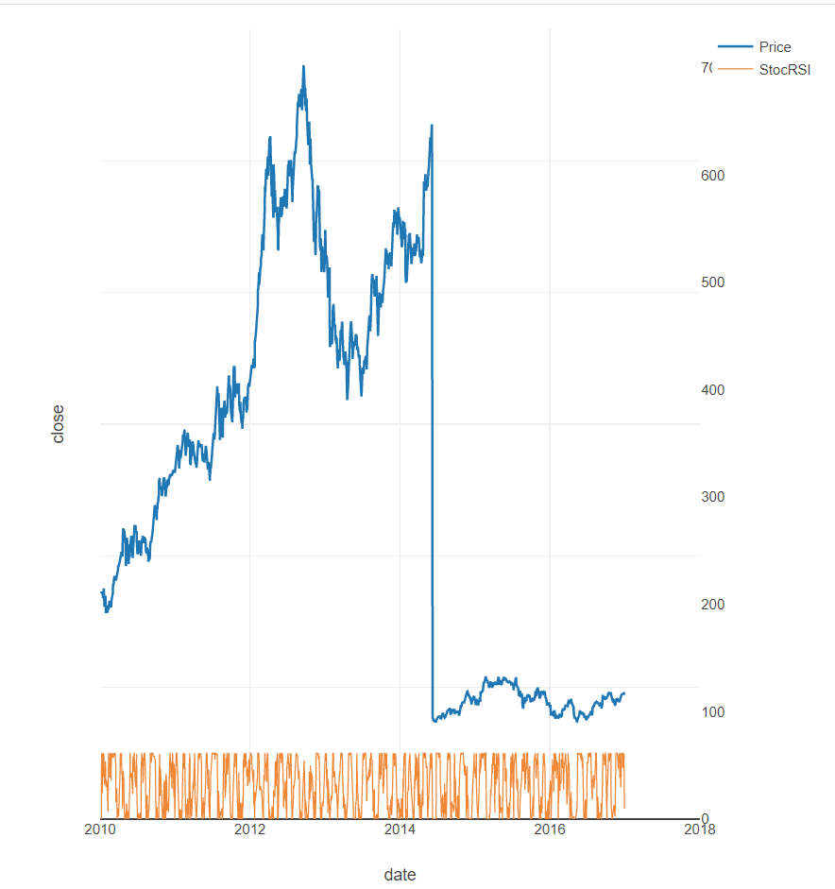

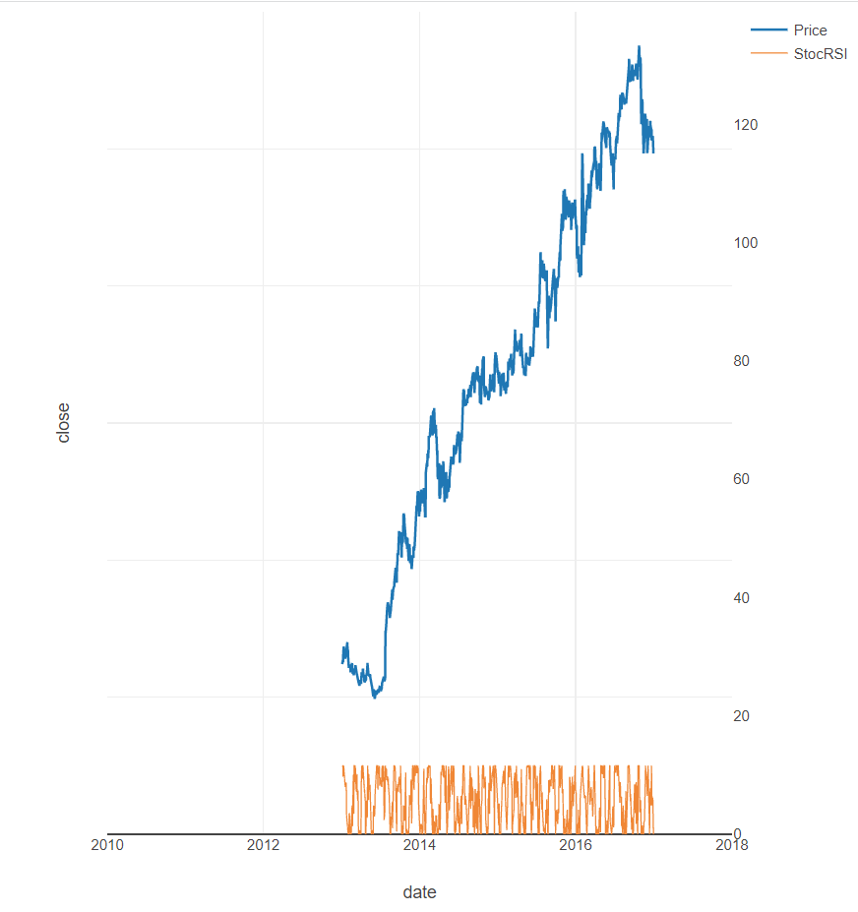

# Review



1. In/Out Category
   1. Input Data (1)
   2. Output Data (2)
2. Preparation Category
   1. Select (3)
   2. Data Cleansing (4)
   3. Filter (5)
   4. Sort (6)
   5. Sample (7)
   6. Formula (8)
   7. Multi-row formula (9)
3. Join Category
   1. Join Multiple (10)
   2. Join (11)
4. Parse Category
   1. DateTime (1)
   2. Text to columns (2)

There are 4 formulas used, the first one includes 2 conditionals if statements

Apart from that I have also used:

1. Reporting Category
   1. Interactive Chart
   2. Render
2. Transform Category
   1. Summarize